
SRM Institute of Science and Technology
Mode of Exam
OFFLINE
SET- B

College of Engineering and Technology
DEPARTMENT OF ECE
SRM Nagar, Kattankulathur – 603203, Chengalpattu District, Tamilnadu
Academic Year: 2021-2022 (EVEN)-Answer Key
Test: CLAT-2 Date: 25.05.2022
Course Code & Title: 18ECE206J Advanced Digital System Design Duration: 1 Hour 40 Minutes
Year & Sem: II & IV Max. Marks: 50

Course Articulation Matrix:
 | 18ECE206J / Advanced Digital System Design | Program Outcomes (POs)
 |  | Graduate Attributes |  |  |  |  |  |  |  |  |  |  |  |  | Program Specific Outcomes (PSO)
S.No. | Course Outcomes (CO): | 1 | 2 | 3 | 4 | 5 | 6 | 7 | 8 | 9 | 10 | 11 | 12 | 1 |  | 2 | 3
1 | Apply advanced theorems to simplify the design aspects of various practical circuits and design Mealy and Moore models of sequential circuit. | 2 | - | 2 | - | - | - | - | - | - | - | - | - | - |  | - | -
2 | Implement synchronous sequential circuits and write VHDL Code | - | 2 | 2 | - | - | - | - | - | - | - | - | - | - |  | - | -
3 | Analyze asynchronous sequential circuits and write code using VHDL. | - | 2 | 2 | - | - | - | - | - | - | - | - | - | - |  | - | -
4 | Implement Hazard free circuits and various digital circuits using Programmable Logic Devices. | - | 2 | 2 | - | - | - | - | - | - | - | - | - | - |  | - | -
5 | Demonstrate FPGAs and Construct digital circuits using VHDL. | - | 3 | 3 | - | - | - | - | - | - | - | - | - | - |  | - | 2
6 | Design and verify the experiments in the laboratory with hardware and software. |  | - | - | - | 3 | - | - | - | 2 | - | - | 3 | 3 |  | - | 2

Part - A
(10 x 1 = 10 Marks)
Instructions: Answer all Questions
Q. No | Question | Marks | BL | CO | PO | PI Code
1 | A signal cannot be declared inside a_____  - Process  - Sequential  - Concurrent  - Wait | 1 | 1 | 2 | 2 | 2.3.1
2 | State reduction in the sequential circuit represents the reduction of  (a) Number of flip flops  (b) Number of OR gates  (c) Number of AND gates  (d) Number of Counters | 1 | 1 | 2 | 2 | 2.3.1
3 | Which of the following is not a Data type?  (a) std_logic_vector  (b) bit_vector  (c) std_bit_logic  (d) bit | 1 | 1 | 2 | 2 | 2.3.1
4 | The result of the shift operation: 1001010 srl3 is  (a) 0001001  (b) 0010010  (c) 1001011  (d) 1111000 | 1 | 1 | 2 | 2 | 2.3.1
5 | what is wrong in the following VHDL code  entity 2and is  port (A, B: in BIT;  Y: out BIT);  end 2and;  (a) port list  (b) entity name  (c) end  (d)entity | 1 | 1 | 2 | 3 | 3.1.1
6 | ___-------____ flow table has only one stable state in each row.  (a) Primitive  (b) Non-primitive  (c) transition  (d) FSM | 1 | 1 | 3 | 2 | 2.1.1
7 | The logic circuit causes the output to go to 0, When it should remain at 1, which produce  - Static 0 hazard  - Static 1 hazard  - Dynamic hazard  - Essential hazard | 1 | 1 | 3 | 2 | 2.1.1
8 | The compatible pairs of the merger diagram are  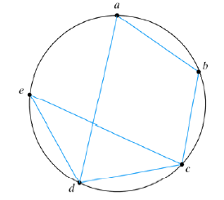  (a) (a,b )(b,c)(c,e)(c,d)(d,e)  (b) (a,b )(b,c)(a,d)(c,e)(c,d)  (c) (a,b )(b,c)(d,e)  (d) (a,b )(b,c)(a,d)(c,e)(c,d)(d,e) | 1 | 2 | 3 | 3 | 3.2.1
9 | The total stable states in the given flow table are  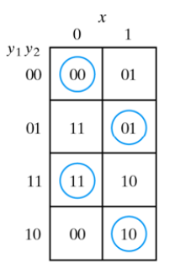  (a) 001,110,101,111  (b) 000, 011,110,101  (c) 000,111,001,101  (d) 001,010,111,100 | 1 | 2 | 3 | 3 | 3.2.1
10 | Next state equation of the given transition table is  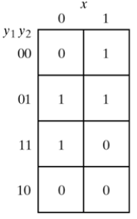  (a) 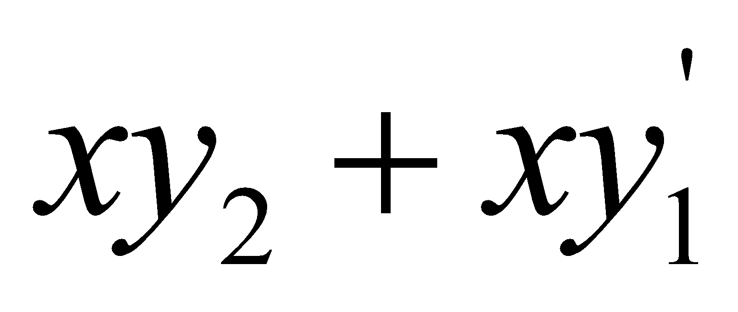  (b) 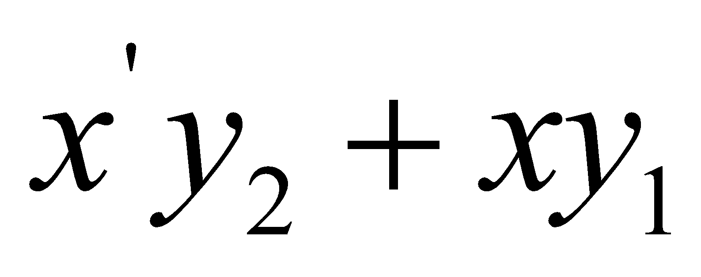  (c)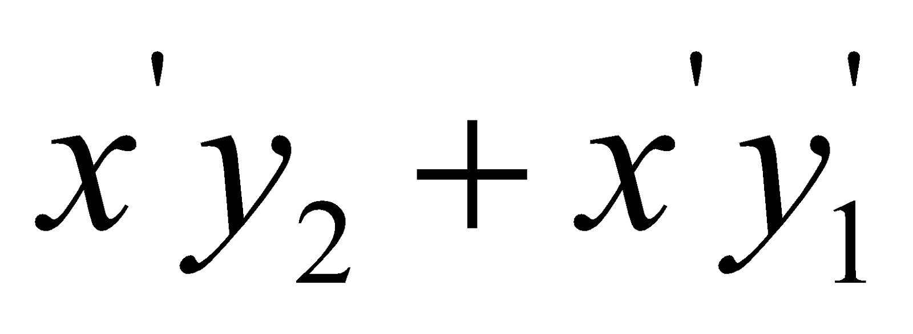  (d) 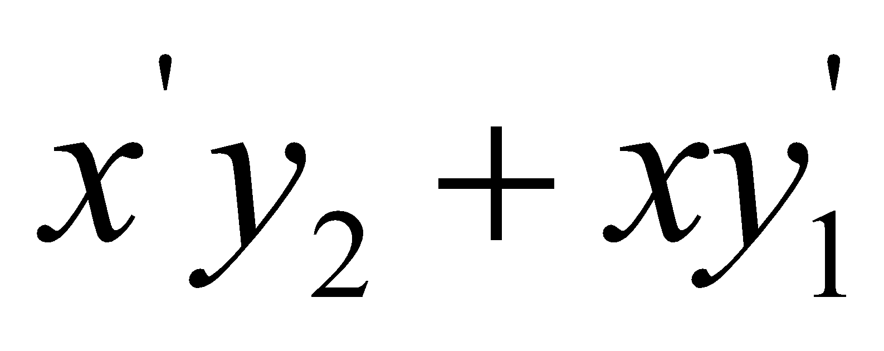 | 1 | 2 | 3 | 3 | 3.2.1
Section- B1
(2 X 10 Marks = 20 Marks)

Instructions: Answer Any Two Questions
11 | (i)Reduce the following table using implication chart (8)  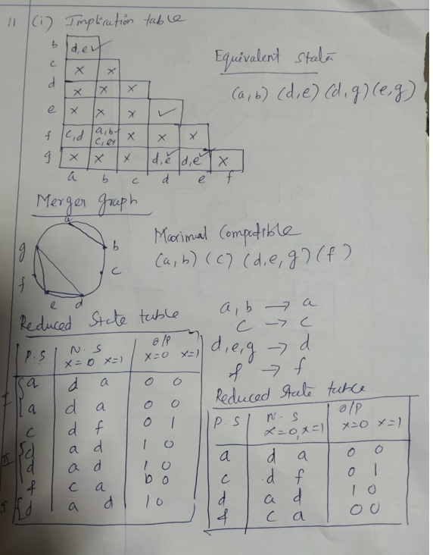  (ii) Write about state assignment and its types. (2)  - In order to design a sequential circuit with physical components, it is necessary to assign  unique coded binary values to the states.  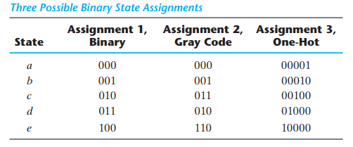 | 10  (8+2) | 2 | 2 | 3 | 3.1.1
12 | - Draw the ASM for the given state diagram 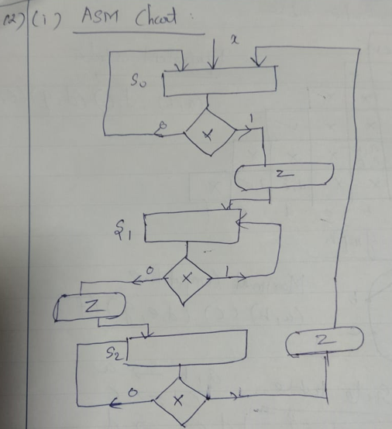  - Explain Scalar data type in VHDL with example (5)  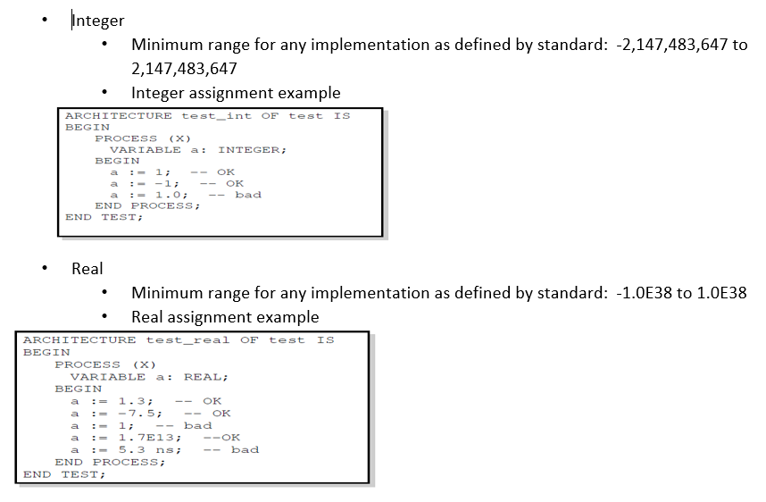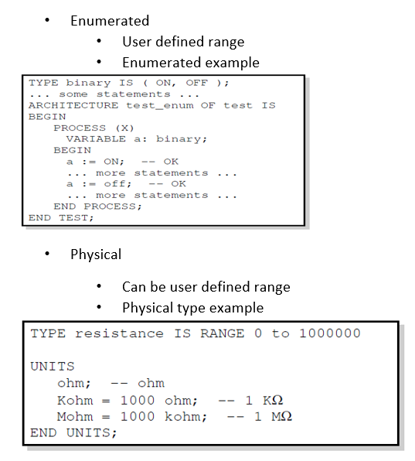 | 5  5 | 3  2 | 2  2 | 3  3 | 3.1.1  3.1.1
13 | - Explain the VHDL operators with example?  Logical Operators: and, or, not, nand, nor, xor, xnor  Relational Operators: = , /=, <, <=, >, >=  Shift Operators: sll, srl, sla, sra, rol,ror  Adding Operators: +, - , &  Multiplying Operators: *, /, mod, rem  - Write a VHDL program for 4 X1 MUX using ‘Case’ statement  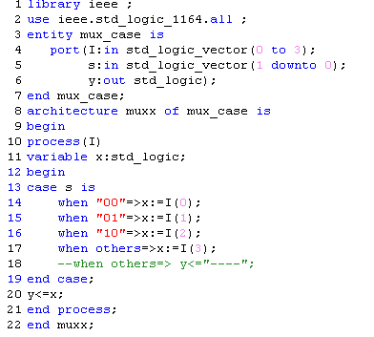 | 5  5 | 2  3 | 2  2 | 2  2 | 2.3.1  2.3.1
Section- B2
(2 X 10 Marks = 20 Marks)

Instructions: Answer Any Two Questions
14 | - Draw the state diagram (5)  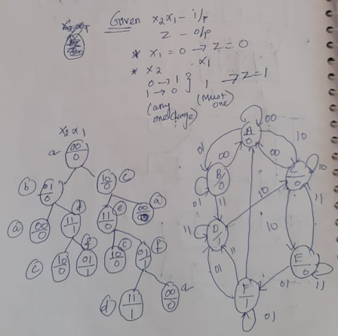  - Construct the primitive flow table (3)  - Derive the reduced flow table (2)  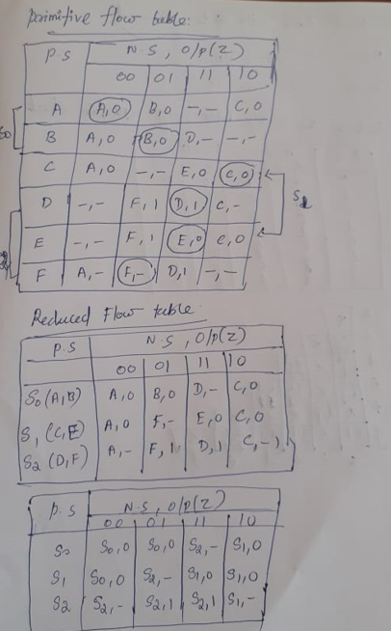 | 10  (5+3+2) | 4 | 3 | 3 | 3.2.1
15 | - Draw the logic diagram of the circuit (4)  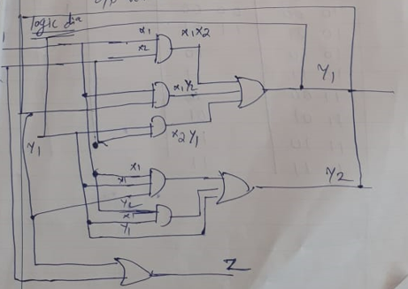  - Derive the transition table and output map. (6)  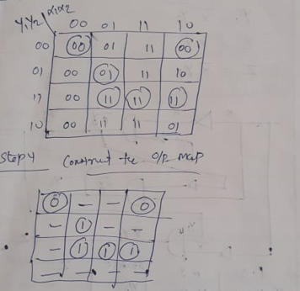 | 10  (4+6) | 3 | 3 | 3 | 3.2.1
16 | Write a VHDL Program to add two four-bit numbers, use full adder as a component.  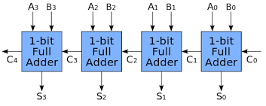  Block diagram ----1 Mark  Full adder program ---2 Marks  RCA program ---7 Marks  Library ieee;  Use ieee.std_l ogic_1164.all;  Entity ripple_str is  port(A:in std_logic_vector(3 downto 0);  B:in std_logic_vector(3 downto 0);  Cin:in std_logic;  sum:out std_logic_vector(3 downto 0);  Cout:out std_logic);  End ripple_str;  Architecture ripple_str_fa of ripple_str is  Signal Cint:std_logic_vector(1 to 3);  Component fa  port(x,y,z:in std_logic; s,c:out std_logic);  End component;  Begin  rip1:fa port map(A(0),B(0),Cin,sum(0),Cint(1));  rip2:fa port map(A(1),B(1),Cint(1),sum(1),Cint(2));  rip1:fa port map(A(2),B(2),Cint(2),sum(2),Cint(2));  rip1:fa port map(A(3),B(3),Cint(3),sum(3),Cout);  End ripple_str_fa; | 10 | 3 | 3 | 3 | 3.2.1
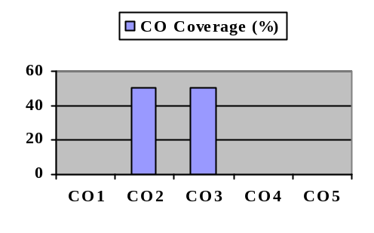Course Outcome (CO) and Bloom’s level (BL) Coverage in Questions
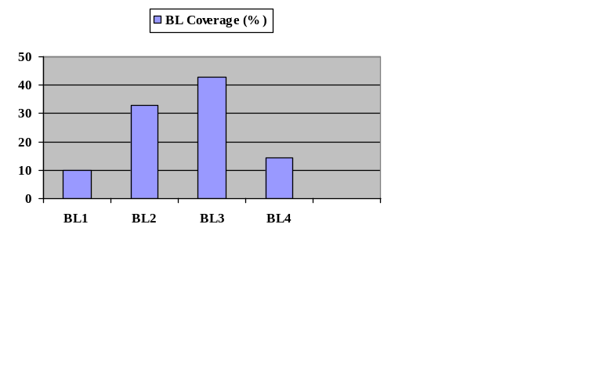

Evaluation Sheet

Name of the Student:
Register No:

Part- A (10x 1= 10 Marks)
Q. No | CO | PO | Marks Obtained | Total
1 | 2 | 2
2 | 2 | 2
3 | 2 | 2
4 | 2 | 2
5 | 2 | 3
6 | 3 | 2
7 | 3 | 2
8 | 3 | 3
9 | 3 | 3
10 | 3 | 3
Part -B
Section -B1 (2 x 10= 20 Marks)
11 | 2 | 3
12(i) | 2 | 3
12(ii) | 2 | 3
13(i) | 2 | 2
13(ii) | 2 | 2
Section -B2 (2 x 10= 20 Marks)
14 | 3 | 3
15 | 3 | 3
16 | 3 | 3

Consolidated Marks:

Marks Scored
CO2
CO3
PO2
PO3
Total

Signature of the Course Teacher

